 |  |  |  | 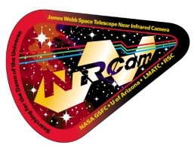
Constellation Classification Cards*
Larry and Nancy Lebofsky and the NIRCam E/PO Team

Background:
The Constellation Classification Cards are meant to be used within the context of a stars and/or constellations unit or as part the Girl Scout Space Science badges. While this is written for Girl Scouts, it is also appropriate for students in elementary and middle school. It is assumed that Girl Scouts are working on their Space Science badges. For students, it is assumed that the students are doing this activity as part of learning about the properties of stars and recognizing constellations.
The cards can be used to reinforce factual knowledge and to assist in classifying stars in a variety of ways. While there are 88 official constellations, we have chosen stars representing nine of the most prominent constellations that are visible from the Northern Hemisphere for the basic set of 20 cards. The extended set of 10 cards includes two additional constellations. Besides the official constellations, there are also patterns of stars called asterisms. These are generally the brightest stars within constellations (the Big Dipper in Ursa Major, for example) or the brightest stars from several constellations (the Summer Triangle, for example, that are the three brightest stars in the constellations Cygnus, Lyra, and Aquila
For Girl Scouts, a basic version of this activity can be found in the Cadette (Space Science Researcher) badge booklet and is called “Classify the Stars.” The Next Generation Science Standards or similar standards have been implemented in all states. The activities presented below are an ideal way for educators to introduce many of the concepts that are contained in the Performance Expectations and Disciplinary Core Ideas for grades 5 to 8. There are two versions of the cards, with the less-detailed set designed for elementary girls and students who may be just learning about stars, patterns in the sky, and sky stories related to those patterns.
Objectives:
The girls/students (we will just use girls from now on to mean Girl Scouts and students) will learn the names and shapes of nine constellations and the properties of 19 stars (11 to 13 constellations and 29 to 52 stars in the extended sets) within these constellations, plus the Sun. They will classify these stars by group (constellation), brightness, distance from Earth, temperature, and color. Girls will learn that even though constellations look like close groups of stars from our viewpoint on Earth, the stars within constellations vary in brightness, distance, temperature, and color. There are two versions of the Constellation Classification Cards, labeled A and B. The first set, A, is designed for students just learning about the constellations and the basic characteristics of stars. In this set, the term brightness is used. In the second set, B, more advanced girls/students are introduced to the additional term, magnitude. In addition, several stars are what are called binaries (a star system with two stars orbiting around their center of mass). In Set B both stars are shown, along with their combined brightness. This set also contains additional information on the stars—their absolute magnitude, their type (size), and their spectral class. This set also lists the temperature as Kelvin instead of degrees Centigrade (see #8 below).
The Cards:
The cards are double sided with their colors (their surface temperatures) on the backs of the cards. We have designed these activities assuming that most groups will be 20 to 30 girls and so include 30 cards (20 basic and 10 additional for larger groups) in the handout that goes with these instructions. We have 23 additional cards with two additional constellations. If you would like copies of these cards, please contact Larry Lebofsky at: lebofsky@psi.edu.
Procedure:
- You may want to make an enlarged copy of any constellation card to share with the group.
- Show the class the sample constellation card. Discuss the information included on the card: name of the constellation, name of a star in the constellation, its brightness, its distance from Earth, its temperature, and its color. If the second set is used, discuss the additional information. Note: The brightness/magnitude scale is designed so that the brightest stars have negative numbers and the fainter stars have larger, positive numbers. Similar to the earthquake Richter magnitude scale, the magnitude scale is non-linear (logarithmic). Each magnitude represents a factor of about 2.5 in brightness, so that 5 magnitudes is exactly a factor of 100 in brightness. Note: you may need to explain absolute magnitude to your students. Absolute magnitude is used so that star brightnesses can be compared. While brightness (magnitude or apparent magnitude) is what we see when we look up at the stars in our sky, absolute magnitude is the brightness of a star as seen from exactly 32.6 light-years (10 parsecs) away. Note: a parsec (parallax second) is a unit of length often used in astronomy when measuring distances beyond the Solar System and is equal to 3.26 light-years.
- OPTION: Show a second card and discuss differences and similarities.
Activity Option #1: Make a human linear model using the cards according to group, distance, temperature, and color.
- Distribute the cards, one per girl. On Page 8 of this activity, we give recommended stars for groups of 20 (30) girls. The sets are designed to assure that there are at least two stars per constellation (except Procyon in Canis Minor) and that the extremes (e.g., hottest/coldest and nearest/farthest) are represented. If you have less than 20 girls, use fewer cards, but try to have two for each constellation.
- Using the Star Classification Information Sheet, ask girls to group themselves by the nine (11/13) constellations plus the Sun. The constellation names can be found at the top of each card with an artistic figure for each constellation on the right. Ask each group to call out their constellation group for all to hear. You can also ask them to call out the names of their stars which can be found in bold on the left of each Card. You can also note that the Sun is not a part of a constellation!
- Begin by telling the girls that stars are like people in several ways. Stars are found in “families” which we call constellations. Ask the girls to form groups with the other members of their constellation family. Ask them to make note of the other girls in their families. Remember, there is only one star card for Canis Minor. Also, our Sun will not have a family. Because the Sun is so close to the Earth, its distance from the Earth is given in light-minutes
- Next, tell the girls/students that family members are not all together all day long. Now we are going to move around into different groups.
- Next, ask the girls to consult their cards and find their brightness/magnitude. This is the second line on the left on the Cards. Have them line up by brightness or magnitude. At this point, you will need to tell/remind them that negative numbers are brighter than positive numbers and that stars with larger positive numbers are fainter than smaller numbers.
- This model requires the girls to stand and move around the room. Forming a large U-shaped line works well; it allows the girls to see the cards other girls are holding. For example, if the open end of the U is facing the teacher, brighter stars begin at the left-hand point of the U (from the perspective of the leader) with the other stars in brightness order so that the faintest stars end at the right-hand point of the U. Ask the girls with brightnesses less than zero (brightest) to start the line on the left. There will be two less than zero: the Sun and Sirius. Then have the students with brightnesses between 0.0 and 0.99 line up next to the first two girls in order of their brightness. If 20 or 30 cards are used, there will be five girls in this group. Continue with brightnesses between 1.0 and 1.99, etc., until all the girls are in line. The girl on the right end will be the one with the star Altais in constellation Draco (if 20 cards are used) or Thuban in the constellation Draco (if 30 cards are used). Note: If you think the girls would be interested, you might ask them how much brighter the Sun is than Altais (or Thuban). The Sun is about 850 (1,500) billion times brighter! For younger girls you can just say a million times a million.
- Ask the girls from each constellation family in turn to identify themselves. Family members will no longer be grouped together because some stars in a constellation are bright, while others are faint.

 |  |  |  |  |  |  |  |  |  |  |  |  |  |  |  |  |  |  |  | 
 |  |  |  |  |  |  |  |  |  |  |  |  |  |  |  |  |  |  |  | 
 |  |  |  |  |  |  |  |  |  |  |  |  |  |  |  |  |  |  |  | 
 |  |  |  |  |  |  |  |  |  |  |  |  |  |  |  |  |  |  |  | 
 |  |  |  |  |  |  |  |  |  |  |  |  |  |  |  |  |  |  |  | 
Brightest |  |  |  |  |  |  |  |  |  |  |  |  |  |  |  |  | Faintest
or |  |  |  |  |  |  |  |  |  |  |  |  |  |  |  |  | or
Closest |  |  |  |  |  |  |  |  |  |  |  |  |  |  |  |  | Farthest
or |  |  |  |  |  |  |  |  |  |  |  |  |  |  |  |  | or
Coolest Hottest

- Next, ask the girls to consult their cards and find their distances from us on Earth. This is the third line on the left on the Cards. Family members can live nearby or farther away. Again, begin the U-shape in the front left corner of the room, starting with the closest stars. Ask the girls with distances less than 25 light-years to start the line. If 20 cards are used, there should be one girl/student representing 8.3 light-minutes (the Sun), one at 8.6 light-years, and one at 11.4 light-years. Consult the Star Classification Information Sheet for other groupings (e.g., 25–49.9 light-years, 50–99.9 light-years, etc.). Have the girls/students for each grouping arrange themselves in the line in order. If you are making a U-shape around the perimeter of the room, the U should again start with the Sun and Sirius, but end with Aludra in Canis Major. Note: 1 light-year = 63,000 AU (astronomical units). 1 AU = 93 million miles or 150 million kilometers (the mean distance of the Earth from the Sun). At the speed of light, it takes light 8.3 minutes to get from the Sun to the Earth, but 8.6 years to get from Sirius to the Earth!
- Ask the girls from each constellation family in turn to identify themselves. Girls should notice that, while constellations may look like stars grouped closely together from our perspective on Earth, these stars may actually be very distant from each other. Two- dimensional drawings of constellations can be very misleading; remind the students that the stars are in a three-dimensional universe. The stars Sirius and Aludra in Canis Major are a good example; one is the closest and one is the farthest in this distance model.
- At this point, you might ask the girls why they think that the Sun is so bright and all the stars are so much fainter—they are much farther away.
- Ask the girls to consult their cards and find the temperature of their stars. This is the fourth line on the left on the Cards. Remind the girls that people have different temperaments; some are really cool, while others are very hot-tempered. Ask them to re- their stars from coolest to hottest. Begin the U-shape at the front left again (as viewed by the leader), beginning with stars that are less than 4,000°C (4,000 K if using Set B). If 20 cards are used, there will be four in this category (only two if using Kelvin), with Antares and Betelgeuse representing the coolest stars. Consult the Star Classification Information Sheet for other groupings to complete the U-shape, ending with Alnitak and Mintaka at 30,000°C (30,000 K). Note: If you look up information on stars, you will see that astronomers always use Kelvin (temperature from absolute zero), not degrees Centigrade (0°C where water freezes). This is a difference of 273°C. However, because star temperatures are usually only approximations, we have rounded when going from Kelvin to degrees Centigrade as in the cases of Alnitak and Mintaka.

Cooler Stars |  |  |  |  | Hotter Stars
 |  | Canis Major, Sirius, temperature: 9,670°C | Taurus, El Nath, temperature: 13,300°C | Orion, Alnitak, temperature: 30,000°C

- Ask the girls/students from the original constellation family groups to identify themselves one group at a time. Notice that both the coolest and hottest stars are from Orion, but that most of the Orion family are represent by stars with hot temperatures.
- Ask the students to remain in temperature order. Ask them to turn over their cards so that the side with the color-coded construction paper is facing out. The students should notice the colors form a pattern, from the coolest stars (red) to the hottest stars (blue). This pattern represents the spectrum of light.

Cooler Stars |  |  |  | Hotter Stars
 | Canis Major, Sirius, color: white | Taurus, El Nath,  color: blue-white | Orion, Alnitak,  color: blue


Group of Girl Scout Leaders with the Original Constellation Cards

- NOTE: It does not matter which way the girls/students are lined up cool to hot: left to right from the perspective of the leader (preferred) or right to left.
Activity Option #2: Classification
- Distribute the cards among small groups of students. Allow the students to study the categories and brainstorm ways to sort the cards. For example, they may be interested in finding all of the blue and blue-white stars in Orion. Record their findings on butcher paper or the white board.
- Discuss patterns, similarities, and differences. For example, the constellations look like they are made up of closely grouped stars from our viewpoint on Earth. Yet the closest and farthest stars represented in the cards are both in Canis Major. Likewise, the coolest and hottest stars represented in the cards are both from Orion.
- Allow the students to graph or chart their chosen characteristics of the stars on paper or as described in Activities #1 and #2 above. This can be done on paper or as a computer graphing activity.
Activity Option #3: Hertzprung-Russell (H-R Diagram) for Card Set B.
- This activity can only be done with the Card Set B which has the stars’ absolute magnitudes. Between 1911 and 1913, Ejnar Hertzprung and Henry Norris Russell independently plotted the spectral types (or temperatures) of stars vs. their absolute magnitudes. This plot was the key to our understanding of stellar evolution and the life cycles of stars.
- Have the students line up in a straight line (not in a U-shape) by temperature as in Activity #1.
- Have them step forward according to their absolute magnitudes. First, have the faintest star, the Sun, at absolute magnitude +4.8 take 1 step forward. Next, have the stars between +4.0 and +2.1 take 2 steps forward (one star). Next, have all the stars between +2.0 and 1.1 take 3 steps forward (three stars if 20 to 30 cards are used). Continue until the last group, -6.0 to -7.9, takes 12 steps forward. The students have recreated the H-R Diagram!
- An H-R Diagram is shown on the left, below. On the right is the same diagram with all 53 of the Constellation Card stars plotted. As you can see, the majority of the stars that we see are among the brightest of all the stars. The Sun is, by far, the faintest.

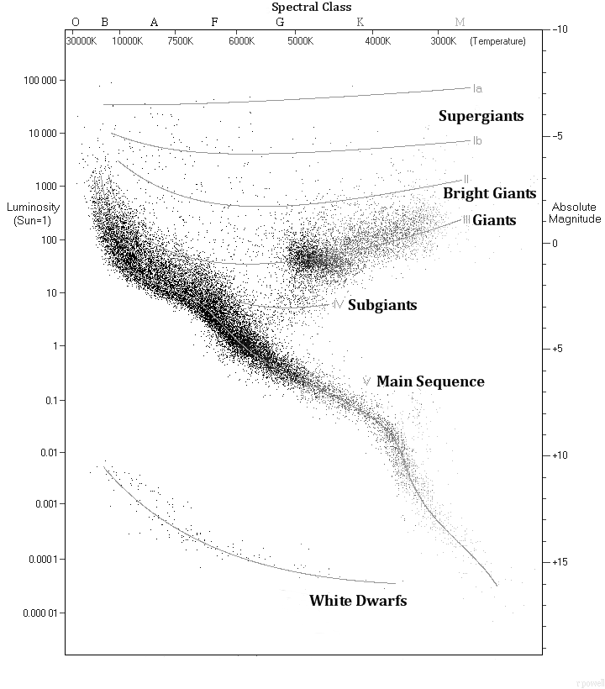 | 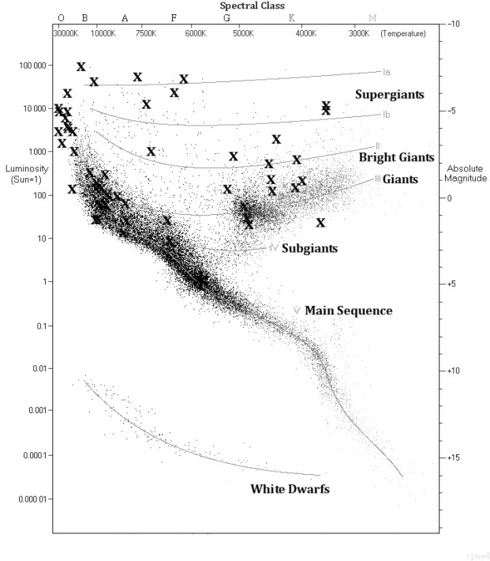

Extensions:
- On the Constellation Classification Cards, as well as on star charts and planispheres, brighter stars appear as larger circles. Learn how to use these aids to find stars.
- After completing the activities, discuss the origins of the star and constellations names. Read or research the myths associated with the constellation names or find other skylore interpretations from other cultures.
- If the students did Activity Option #3, have them research the brightest stars and the nearest stars. Wikipedia has lists that include nearly 100 of each. Have them plot these stars on an H-R Diagram. They will find that only a few stars are common to both lists. This reinforces the concept that the stars that we see in the sky are generally not the nearest stars to us. In terms of absolute magnitude, the Sun is, by far, the faintest star we can see. However, most of the nearest stars are fainter than the Sun and too faint for us to see without a telescope.
- We have developed an activity that lets the participants plot the nearest and brightest stars. If you are interested in that activity, please contact Larry Lebofsky at lebofsky@psi.edu.
Star Classification:
When girls line up to classify the stars by brightness, distance, etc., you may want them to form groups/families: 1,000 light-years or greater from the Earth, for example. The number in each group will depend on how many cards you use, so we have listed below suggested groups, but not the number of stars in each group.
Brightness (Magnitude): Brighter than 0.0, 0.0–0.99, 1.00–1.99, 2.00–2.99, 3.00–4.00
Distance (Light-years): less than 1, 1–24, 25–49, 50–99.9, 100–199, 200–499, 500–999, 1000 or greater
Temperature (Centigrade or Kelvin): less than 4,000, 4,000–5,999, 6,000–7,999, 8,000–9,999, 10,000–29,999, 30,000 or greater
Color: Blue, Blue-White, White, Yellow-White, Yellow, Yellow-Orange, Orange, Red
Absolute Magnitude (for Set B): Brighter than -6.0, -6.00 to -4.01, -4.00 to -2.01, -2.00 to -0.01, 0.00 to 1.99, 2.00 to 3.99, 4.00 or fainter
Type (Size) (for Set B): Supergiant, Bright Giant, Giant, Subgiant, Main Sequence (Dwarf)
Spectral Class (for Set B): O, B, A, F, G, K, M

*Loosely derived from a presentation by Vivian Hoette at an NSTA conference in 1995 and subsequently published in “Adler Planetarium Stars Cards Lesson Plan: Among the Winter Stars,” 1995.
Recommended Constellation Cards:
Below are our recommended groups of stars. The files that contain these stars are labeled.

Base Set —Cards One to Twenty:
Star | Constellation | Characteristic |  | Star | Constellation | Characteristic
Sun | None | our star |  | Rigel | Orion | bright
Procyon | Canis Minor | close & bright |  | Betelgeuse | Orion | bright & cool
Capella | Auriga | close & bright |  | Mintaka | Orion | hot
Menkalinan | Auriga | close |  | Alnitak | Orion | hot
Aludra | Canis Major | far |  | Antares | Scorpius | cool
Sirius | Canis Major | close & bright |  | Shaula | Scorpius | hot
Eltanin | Draco |  |  | El Nath | Taurus
Altais | Draco |  |  | Aldebaran | Taurus
Regulus | Leo | close |  | Dubhe | Ursa Major
Denebula | Leo | close |  | Merak | Ursa Major | close

Extended Set—Cards Twenty-one to Thirty, Add:
Star | Constellation | Characteristic |  | Star | Constellation | Characteristic
Deneb | Cygnus | far |  | Zosma | Leo | close
Albireo | Cygnus |  |  | Thuban | Draco
Arneb | Lepus | far |  | Rastaban | Draco
Nihal | Lepus |  |  | Mizar | Ursa Major | close
Algieba | Leo |  |  | Alkaid | Ursa Major | hot

Extended Set—Cards Thirty-one to Fifty-three, Add:
Star | Constellation | Characteristic |  | Star | Constellation | Characteristic
Pollux | Gemini | close |  | Alnilam | Orion | hot
Mu  Geminorum | Gemini | cool |  | Saiph | Orion | hot
Alhena | Gemini |  |  | Phecda | Ursa Major | close
Castor | Gemini | close |  | Alioth | Ursa Major | close
Schedar | Cassiopeia |  |  | Mirzam | Canis Major | hot
Caph | Cassiopeia | close |  | Adahara | Canis Major | hot
Sadr | Cygnus |  |  | Theta Aurigae | Auriga
Delta Cygni | Cygnus |  |  | Iota Aurigae | Auriga
Sargas | Scorpius |  |  | Gamma  Cassiopeiae | Cassiopeia | hot
Dschubba | Scorpius | hot |  | Ruchbah | Cassiopeia | close
Bellatrix | Orion | hot |  | Wesen | Canis Major | far
Iota Orionis | Orion | hot

